Steps to run the Django Project

**Step 1**: Download **Python** (Version **3.6x** or later) and install **pip**

**Step 2:** Create a **virtual environment**

**Step 3:** Run the following command on your terminal

pip3 install -r requirements.txt

**Step 4**: Go to the following directory :

Users/views.py

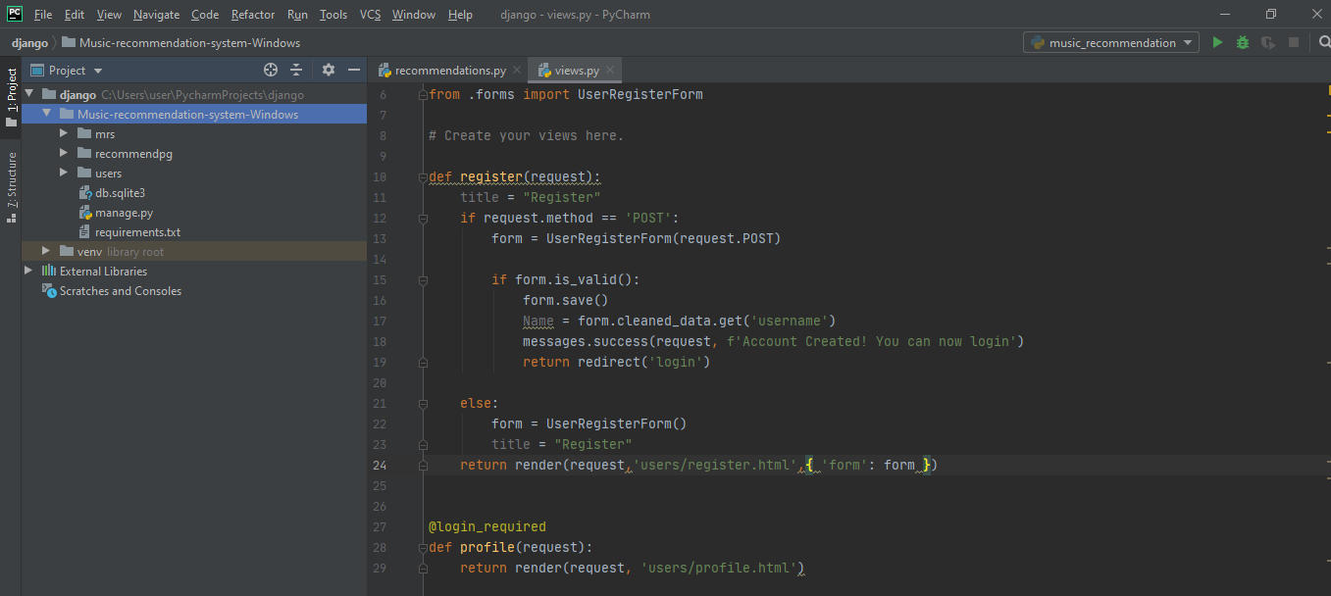

Remove the last argument **{‘title’:title}** from the **Register** function

( i have already deleted the argument)

**Step 5**: Go to the following directory

mrs/settings.py

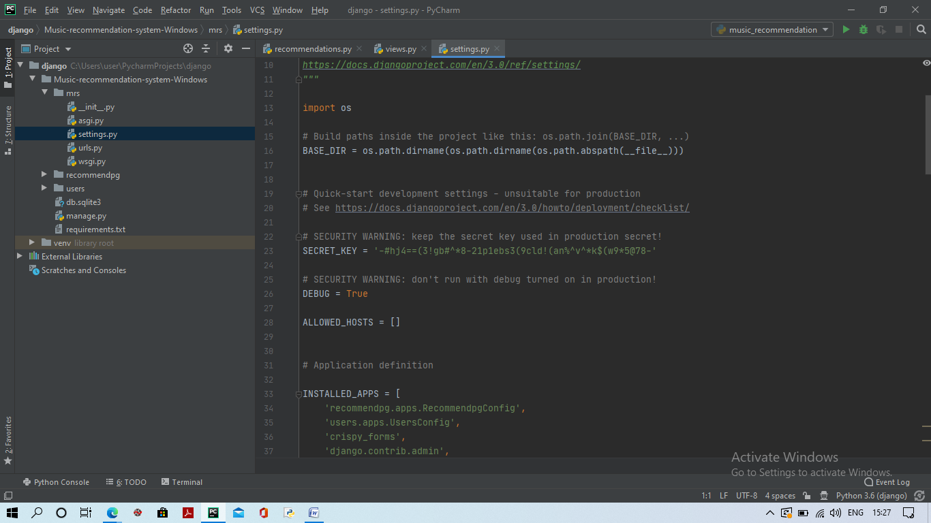

And find the area that says **SECRET_KEY** and change it’s value to the value provided (SECRET_KEY.txt file)

**Step 6:** There should be a zip file named **spotify-music-genre-list** you should install it in a **specified directory** (remember the directory where you have saved the file) and extract the file. You should get a file named

**SongDb.tsv**

**Step7:** Go to the directory called

recommendpg / recommendations.py

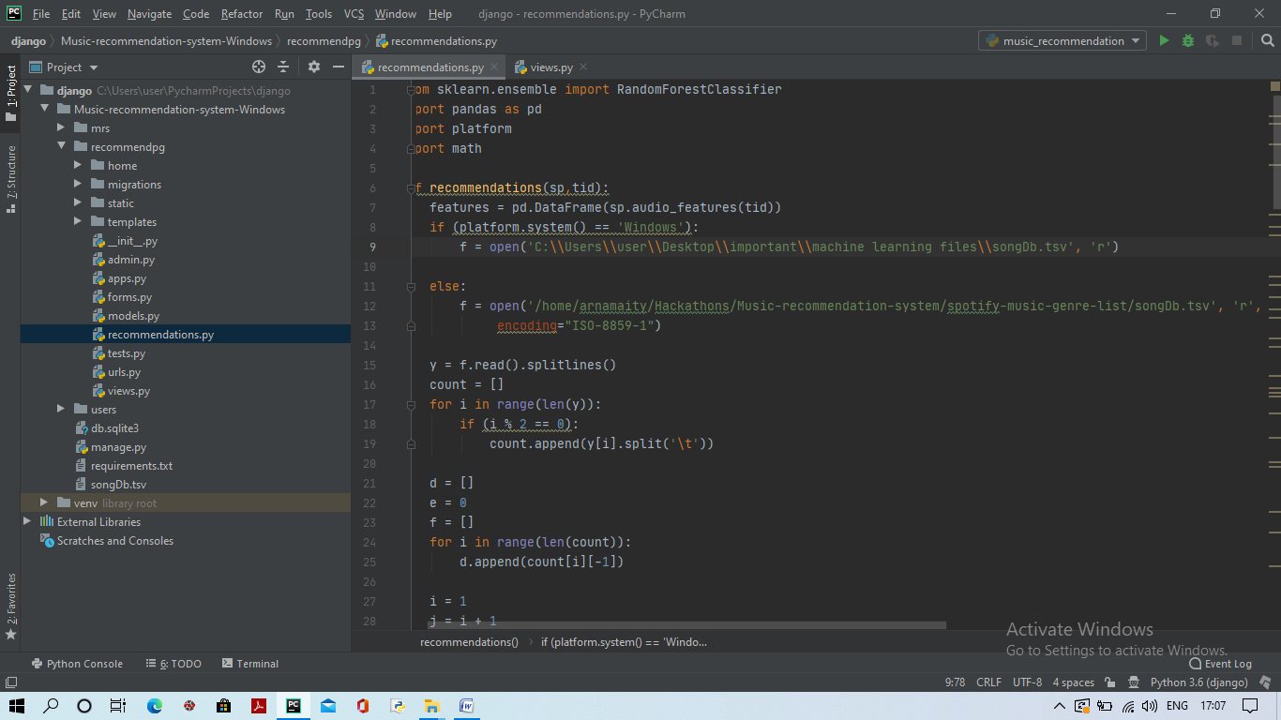

and change the directory to **the directory** where you have saved the file **SongDb.tsv**

(in my case I have saved my file Songs.tsv inside the directory C:\\Users\\user\\.......\\songDb.tsv)

**Step 8**: Run the following command on your terminal

python manage.py migrate

Or

python3 manage.py migrate

**Step 9**: Finally run the deployment server using the following command in the terminal

Python manage.py runserver 127.0.0.1/8000

Or

Python3 manage.py runserver 127.0.0.1/8000

**Step 8**: In the terminal you will see a website named Http//127.0.0.1/8000

Click the site and then browser will open with the site. YOU HAVE TO ADD **/home/**  after it.

Finally the website will become **http//127.0.0.1/8000/home/**

**DONE**